Membership Meeting and CME Program
Tuesday, November 13, 2012 - 6:00 pm • Goodwood Museum & Gardens Carriage House
DOMESTIC VIOLENCE
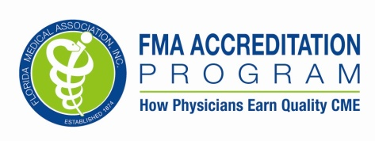
Presented by
Suzanne Leonard Harrison, MD, FAAFP
Associate Professor and Education Director, Family Medicine,
Florida State University College of Medicine

This course fulfills the Florida requirement for 2 hours of Domestic Violence education every third renewal period.
Dr. Harrison has no relevant financial relationships. Planners: Dr. Inglese is on the speaker’s bureau of Warner Chilicott. Dr. Ortiz is on the speaker’s bureau of Pfizer, Novartis, Glaxo, and Allergan. Dr. Rackley serves as a consultant to Intuitive Surgical and is on the speaker’s bureau of Astellas. Dr. Brafford, Ms. Carlin, Dr. Chumney, Dr. Harrison, Dr. Hellgren, Dr. Krishnamoorthy, Dr. Paquette, Dr. Rahangdale, Dr. Stewart and Dr. Sain have disclosed no financial relationships.

Presenting Sponsors:




Supporting Sponsor:
Navy Recruiting District Jacksonville

Meeting Sponsors:
Capital City Bank
MAG Mutual
Tallahassee Primary Care Associates

Seating is limited. We request you register by November 8, 2012
Name (please print clearly):______________________________________________________________________________________
Email Address: ____________________________________________________________________________________________
Return to:
Capital Medical Society, 1204 Miccosukee Road, Tallahassee, FL 32308 Fax: 878-0218

Objectives:
Following this activity, participants will be able to:
Define domestic violence, including the description in the Florida Statutes. Review the state laws regarding mandatory reporting by a medical provider. Describe the impact of domestic violence. Understand the prevalence of domestic violence.
Review recommendations for screening for domestic violence. Identify community resources for victims and perpetrators of domestic violence.
Accreditation Statement:
This Activity is Jointly Sponsored by The Florida Medical Association
This activity has been planned and implemented in accordance with the Essential Areas and policies of the Accreditation Council for Continuing Medical Education through the joint sponsorship of the Florida Medical Association and Capital Medical Society. The Florida Medical Association is accredited by the ACCME to provide continuing medical education for physicians.
The Florida Medical Association designates this live activity for a maximum of two (2.0) AMA PRA Category 1 CreditsTM.
Physicians should claim only the credit commensurate with the extent of their participation in the activity.

