

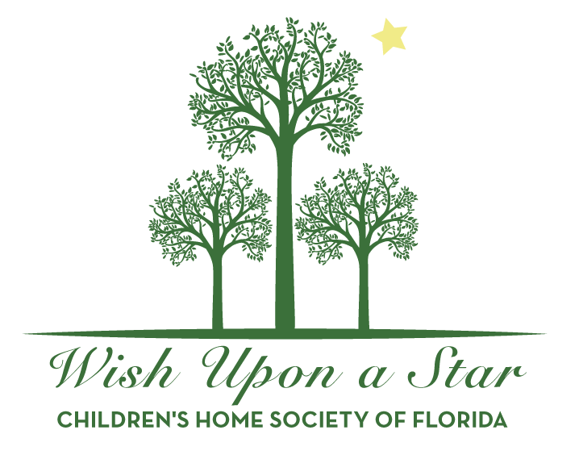
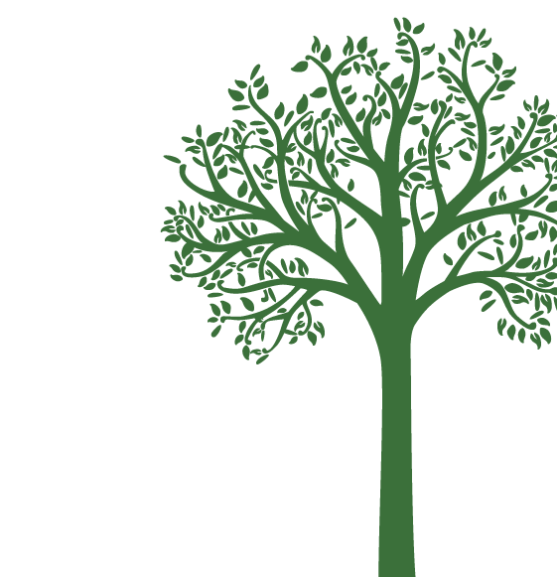
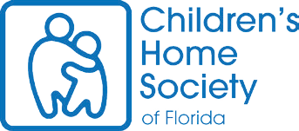
Contact name

Ticket contact (if different from above) Address
City/State/Zip

TelephoneFax
Email
3. Please submit table guest names and program ad to Anna-Kay Hutchison:
Please choose one:
 Enclosed is my check made payable to Children’s Home Society of Florida
 Please invoice my organization
 Please bill my credit card
Please circle: MasterCard Visa Amex Discover

// Credit Card #Expiration date

Name exactly as it appears on the card

Authorized signature

For additional information, please call 850.219.4205 or email

About Children’s Home Society of Florida chsfl.org/northcentral ² About Wish Upon a Star chsfl.org/wish

CHILDREN’S HOME SOCIETY OF FLORIDA, REGISTRATION #CH180, IS REGISTERED WITH THE STATE UNDER THE SOLICITATION OF CONTRIBUTIONS ACT. A COPY OF THE OFFICIAL REGISTRATION AND FINANCIAL INFORMATION MAY BE OBTAINED FROM THE DIVISION OF CONSUMER SERVICES BY CALLING TOLL-FREE (800-435-7352) WITHIN THE STATE OR BY VISITING REGISTRATION DOES NOT IMPLY ENDORSEMENT, APPROVAL OR RECOMMENDATION BY THE STATE.

Friday, October 20, 2017 ² Goodwood Museum & Gardens
COMMITMENT FORM

Please indicate level of support:
 Presenting Sponsor, Live Oak - $10,000 (FMV $2,800 ² $7,200 is tax deductible)
 Southern Cypress - $7,500 (FMV $2,400 ² $5,100 is tax deductible)
 Magnolia - $5,000 (FMV $1,200 ² $3,800 is tax deductible)
 Maple - $2,500 (FMV $600 ² $1,900 is tax deductible)
 Dogwood - $1,250 (FMV $400 ² $850 is tax deductible)
*Sponsorship assets available for support levels of $2,500 and above

Please complete the form below and mail, fax or email to:
Children’s Home Society of Florida ² Attn: Anna-Kay Hutchison
1801 Miccosukee Commons Drive ² Tallahassee, FL 32308 ² Fax: 850.921.0726 ² Annakay.hutchison@chsfl.org

Organization/Donor name (as it should appear in materials)

