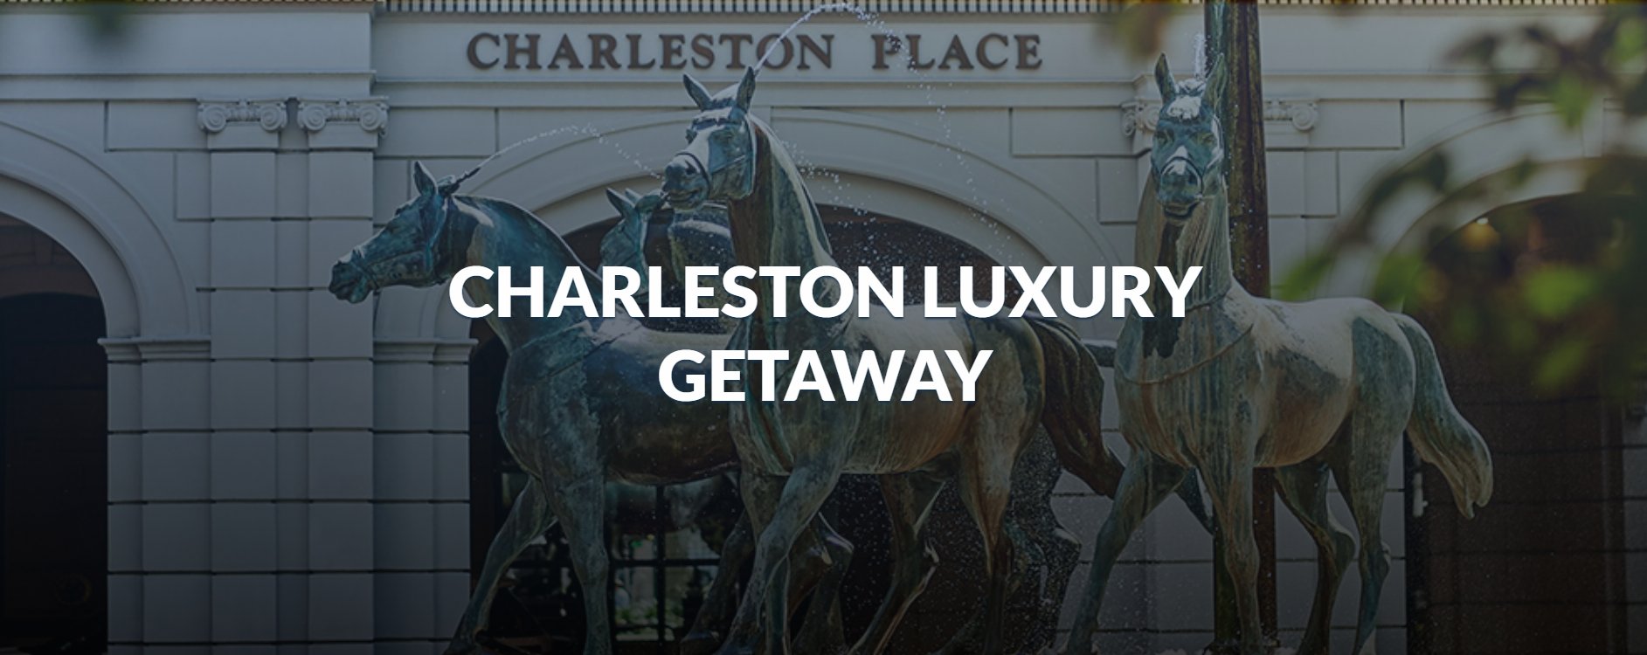
Starting Bid: $3,000
Minimum Raise: $500
Value: $3,726
Charleston Luxury Getaway
Private Historical Photo Tour of Charleston (South Carolina), Dinner at Charleston Grill, Charleston Place 3-Night Stay for 2
This Experience Includes:
- 3-night stay in a deluxe room at the Charleston Place Hotel
- Daily breakfast for 2
- 2 hour private Charleston history and photo walking tour for 2
- Dinner for 2 at Charleston Grill
- Winspire booking & concierge service

A living postcard of Southern colonial grandeur, Charleston enjoys a gentler way of life. This historic city, located on the southern coast of South Carolina, is a friendly destination, offering clean beaches and stately restored homes from the 17th and 18th centuries. Best of all, the mild climate means you can enjoy most of the sights year-round.
Charleston Place Hotel
Enjoy a 3-night stay for two in a deluxe room including daily continental breakfast in the Palmetto Cafe at one of the finest hotels in Charleston. Located in the heart of historic downtown Charleston, Charleston Place has long been revered as the city’s iconic luxury hotel. A perennial Conde Nast Traveler and Travel + Leisure favorite, this landmark destination features new guest rooms, a rooftop pool, and Four Diamond dining.
Enjoy the comprehensive health club, equipped with a beautiful indoor/outdoor pool and children's splash pool. The horizon-edged saltwater mineral swimming pool is heated for year-round comfort, and the glass roof retracts for fresh-air "outdoor" sunbathing. Steps from the historic City Market, renowned restaurants, and boutique shopping, experience the unrivaled charm of the Best City in the World from its best address.
Private Charleston History and Photo Tour for 2
Experience Charleston's incomparable beauty, unique history, and flourishing preservation with your private guide whose knowledge of Charleston's heritage, culture, and architecture are unmatched. Your 2 hour private VIP walking tour can be customized to what interests you most, which may include magnificent mansions, mysterious graveyards, graceful gardens, Revolutionary and Civil War sites, secret passageways, cobblestone streets, slave history, various locations to capture unique photographs, and photographic tips on how to compose the perfect shot.
Charleston Grill
Enjoy dinner for two at this 4-starrestaurant, recipient of the AAA 4-Diamond award and Distinguished Restaurants of North America Award. The Charleston Grill, located within the Charleston Place Hotel, offers contemporary Lowcountry cuisine featuring fresh local produce, seafood, and game, prepared with a French accent. Emphasis is placed on the quality of the ingredients, unique presentations, and sophisticated textures. After dinner, enjoy the soft sounds of live jazz of The Quentin Baxter Jazz Trio in an elegant, but casual setting.
Winspire Booking & Concierge Service
Winspire provides a team of seasoned travel professionals who will help you redeem your experience. All travel-related details and reservations are handled for every part of your Winspire experience. Operating as a full-service travel agency, Winspire can assist with extra hotel nights, airfare, and additional guests. This service also provides you with an established network of onsite contacts who can help you book additional experiences, activities, and tours.
ADDITIONAL INFORMATION:
Travel must be completed within two years from the date of purchase. Reservations are subject to availability and must be booked a minimum of 60 days prior to travel. Ground transportation is the responsibility of the winner unless otherwise stated. Certificates cannot be replaced if lost, stolen, or destroyed. Purchases through charity fundraisers are non-refundable and packages cannot be resold.
