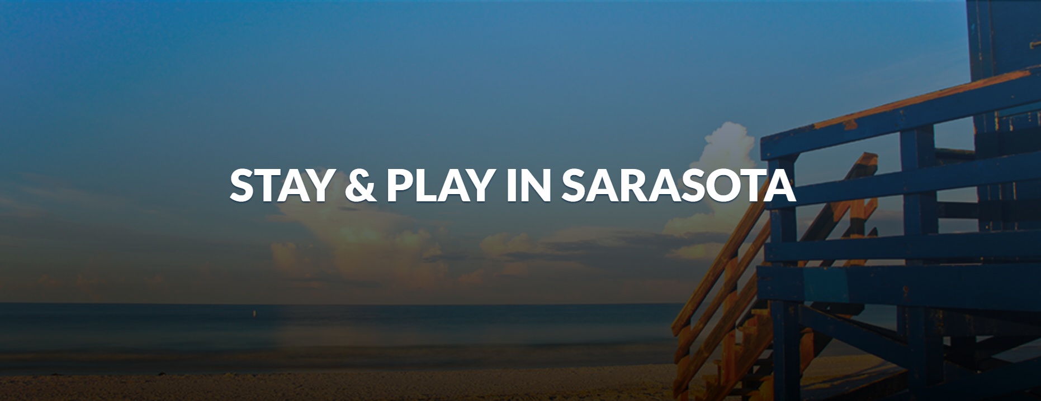
Starting Bid: $2,090
Minimum Raise: $200
Value: $2,140
Stay & Play in Sarasota
2-Night Stay in Sarasota (Florida), Personal Tour and Dinner for 2
This Experience Includes:
- Sarasota personal tour with dinner for two
- 2-night stay in Sarasota
- Winspire booking & concierge service

Sarasota Personal Tour and Dinner
Sarasota is known for its sugary white beaches, rich cultural amenities, and Ringling Circus heritage. Enjoy a personalized journey with your own dedicated guide for a two-hour private tour. View landmarks such as Siesta Key, Ringling Museum, St. Armand's Circle, and more. Your day concludes with a delicious dinner at a local farm-to-table downtown restaurant. Alcohol is not included.
Hotel Accommodations
Enjoy a 2-night stay in a standard guest room at a Courtyard by Marriott, Hyatt Place, Hilton Garden Inn, or comparable Sarasota hotel. Exact property to be selected/determined.
Winspire Booking & Concierge Service
Winspire provides a team of seasoned travel professionals who will help you redeem your experience. All travel-related details and reservations are handled for every part of your Winspire experience. Operating as a full-service travel agency, Winspire can assist with extra hotel nights, airfare, and additional guests. This service also provides you with an established network of onsite contacts who can help you book additional experiences, activities, and tours.
ADDITIONAL INFORMATION:
Travel must be completed within two years from the date of purchase. Reservations are subject to availability and must be booked a minimum of 60 days prior to travel. Ground transportation is the responsibility of the winner unless otherwise stated. Certificates cannot be replaced if lost, stolen, or destroyed. Purchases through charity fundraisers are non-refundable and packages cannot be resold. Blackouts may apply during holidays and special events.
