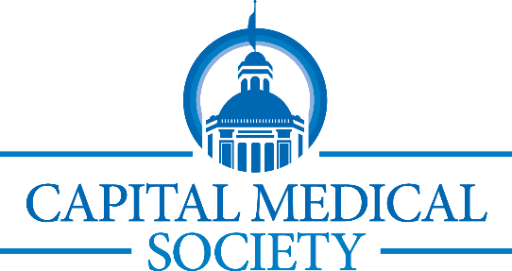 2025 Calendar

May 13 | Membership Meeting & Physician Wellness Program  Mastering Sleep for Physicians: A Science-Based Approach—Dr. Daniel Baughn
May 14 | Lunch & Learn: “From Attendance to Engagement: Unlocking the Potential of Your Team”
June 5 or 8  June 18 | CMS Pickle Ball Night/Day (tentative)  Lunch & Learn: Legislative Update from FMA
August 19 | CME & Membership Meeting  Advances in Trauma Medicine--George P. Pennington, M.D. & Megan L. Morrow, M.D.
August 20 | Lunch & Learn: Effective Communication
August 28 | Evening Rounds with Capital Medical Society  Networking Night with FSU College of Medicine Students
September 13 | CMS Family Day-Challenger Learning Center
September 16 | Membership & CME Meeting: AI in Medicine--Sam Ashoo, M.D.
September 17 | Lunch & Learn: Adverse Incidents
October 15 | Lunch & Learn: Panel Discussion-HR Best Practices
October 21 | CME & Membership Meeting: Prevention of Medical Errors 2-hour required CME  Julia Weeks, M.D., & E. Victoria "Tori" Penny, Penny Stephens Law, PLLC
October 28  November 13  November 19 | Community Physician Reception  CMS Trivia Night at Ology (tentative)  Lunch & Learn: Employment Law-Current Trends
December 4 | CMS Foundation Holiday Auction  50th Anniversary Celebration

