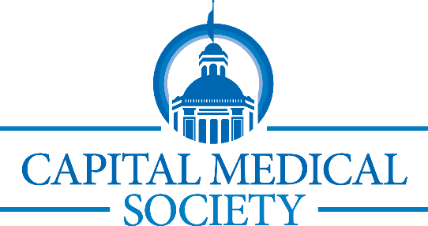 2026 Calendar
Jan 27  Feb 11  Feb 12  Feb 16  Mar 5  Mar 11  Mar 24  Apr 14  Apr 15  May 13  May 19  June 6  June 17 | 2026 CMS Presidential Installation of Dr. John L. Meade  CMS Lunch & Learn  2026 Billing Changes in a Medical Practice  Membership Meeting/CME  Obesity and Eating Disorders, and the Impact of Nutrition and GLP-1 Medications  CMS ’Takeover’ of Elder Care Meals on Wheels  CMS Trivia Night at Ology Northside  CMS Lunch & Learn  Managing Employee Social Media without Breaking the Law  Celebration Awards Dinner  Honoring Drs. Tom Truman and Dan Kaelin  Membership Meeting/CME  Why Drilling Isn’t Enough: Managing Dental Caries Like any other Chronic Disease  CMS Lunch & Learn --Emotional Intelligence  CMS Lunch & Learn  Florida Legislative Session Recap  Special Event at Goodwood: Continuing Medical Education:  Caring for patients with Opioid Use Disorder:  Current evidence, Legal Issues, and Lived Experience  Physician Wellness Family Fair-The Pickle Pad  CMS Lunch & Learn-Topic TBD
July TBD  July 31-Aug 2  Aug 11 | Community Service Project-Second Harvest  Florida Medical Association-Annual Meeting (Orlando)  Celebration of new FMA President Dr. Alma Littles  Dean-FSU College of Medicine, CMS Member and Past CMS President  Membership Meeting/CME  Advancements in Treatment of Colorectal Surgery
Aug 19 | CMS Lunch & Learn  Overview of Brevium Platform and how it Supports Patient Reactivation and Practice Growth
Aug or Sept | Evening Rounds with Capital Medical Society  Networking Night with FSU College of Medicine Students
Sept 16  Sept or Oct | CMS Lunch & Learn--HR Risk Management  CMS Trivia Night at Ology Northside (tentative)
Oct TBD  Oct 20 | Community Physician Reception  CME & Membership Meeting: 2-hour required CME  Domestic Violence and Human Trafficking
Oct 21  November 18 | CMS Lunch & Learn-Cyber Security  CMS Lunch & Learn—Topic TBD
December 3 | CMS Foundation Holiday Auction

